Module 7 :Docker

Lab 1: Create & Run a Basic Docker Container
- How do you create a Docker container using an Ubuntu base image?
- How do you run a simple “Hello World” script inside the container?
O/p
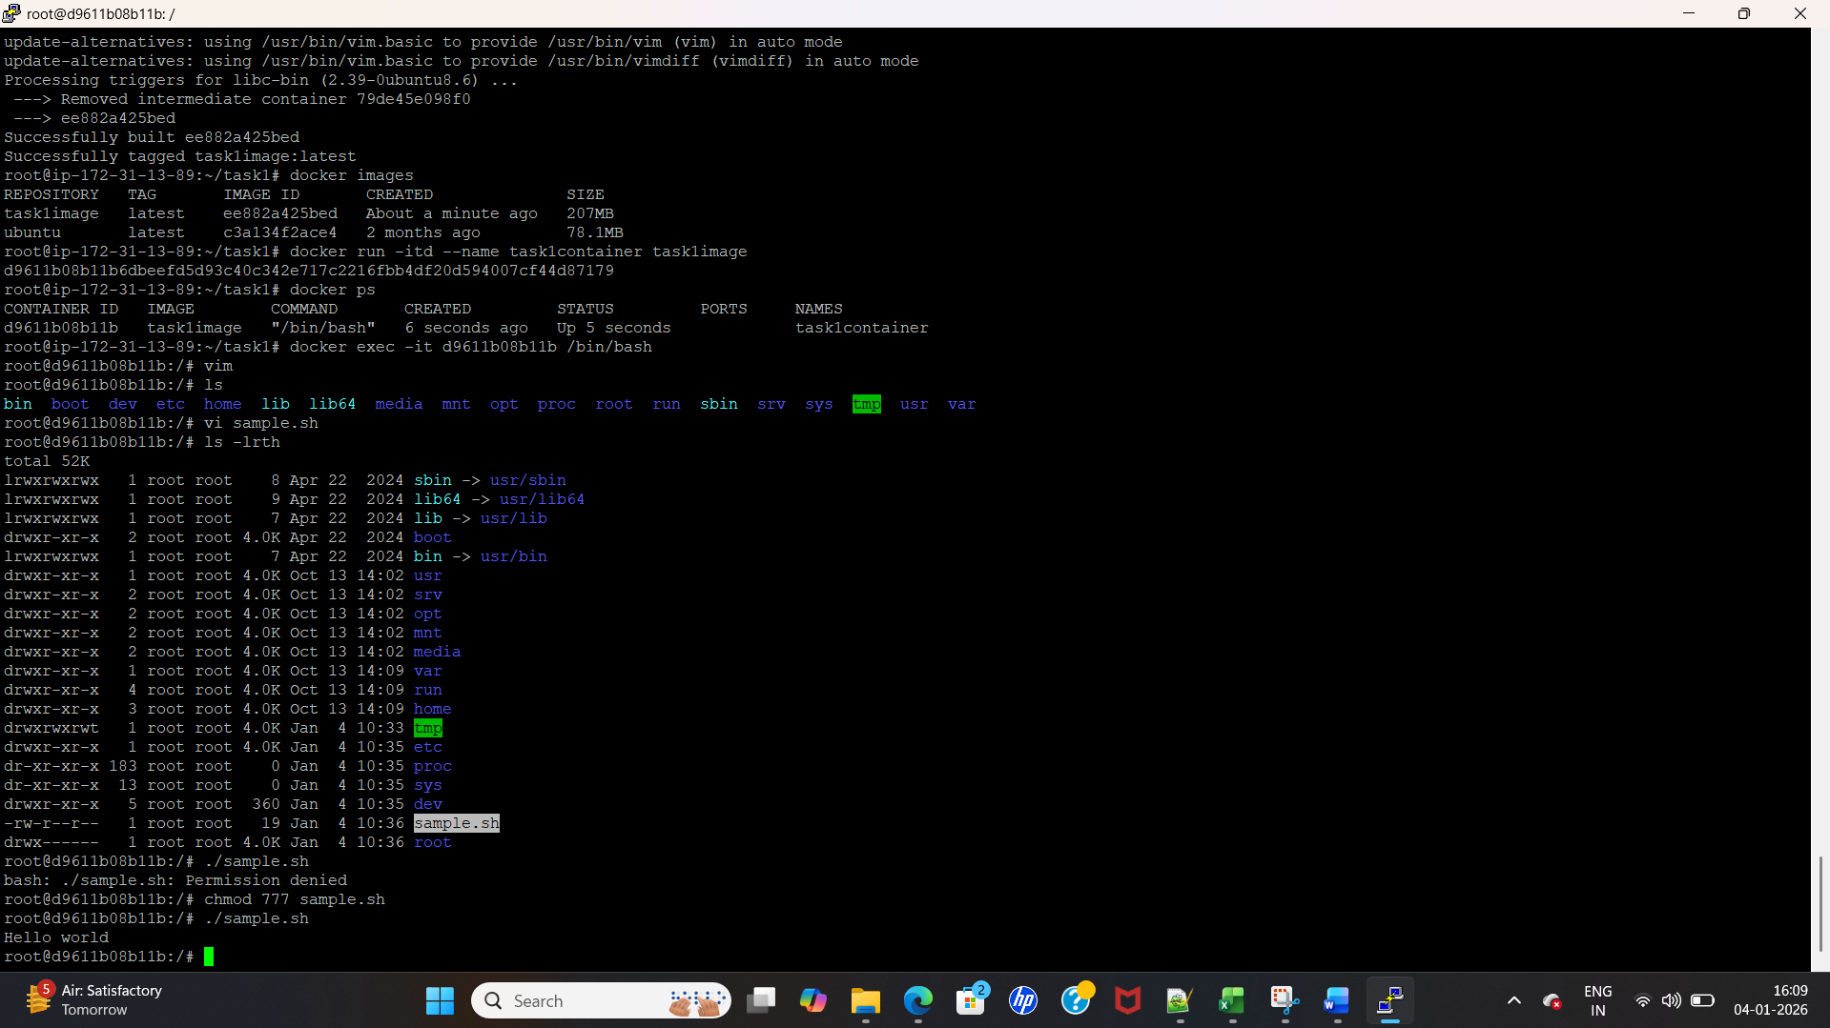
Steps ad commands:
1. AWS server login
2. Sudo apt-get update
3. install docker engine
apt-get install docker.io - y
4.create a directory
5. docker file
FROM ubuntu
MAINTAINER Suba
RUN apt-get update
RUN apt-get install vim -y

6.build the image
docker build -t task1image .
7.run the container.
docker run -itd --name task1container task1image
docker exec -it d9611b08b11b /bin/bash

Lab 2: Build a Custom Nginx Image
- How do you write a Dockerfile that builds a custom Nginx image?
- How do you configure that image to serve a static HTML page?

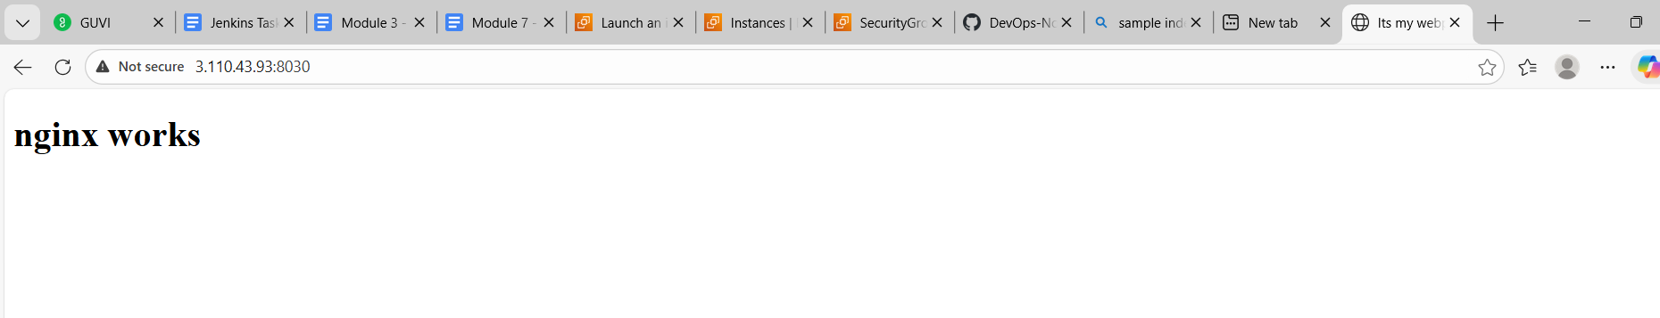

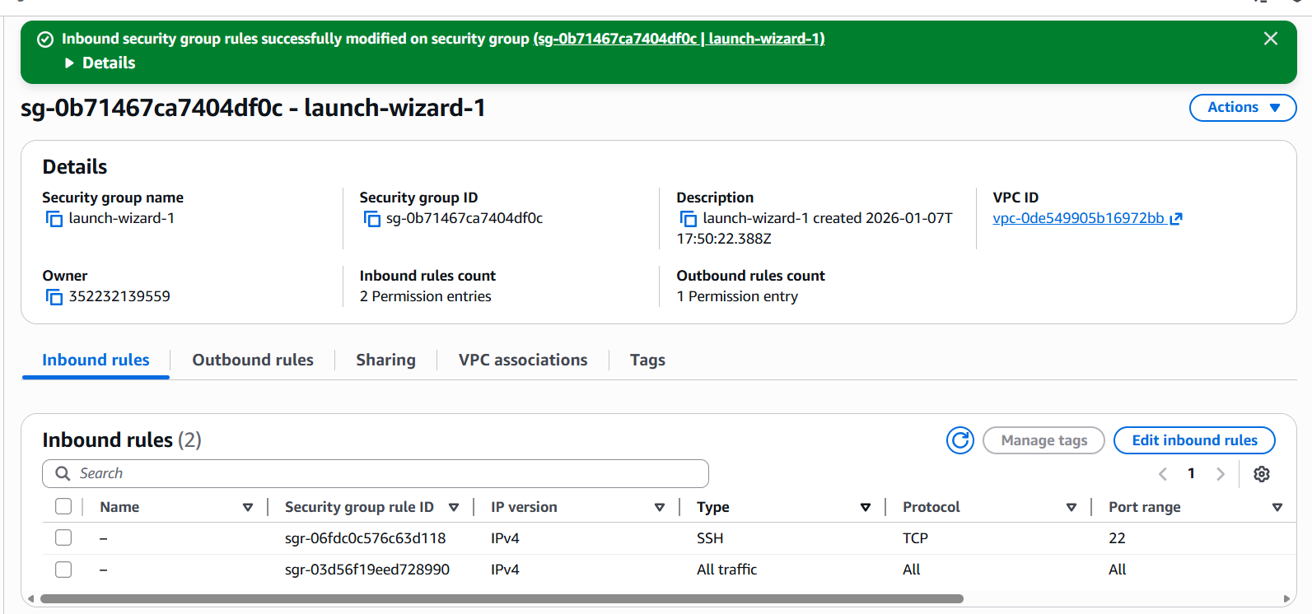

Task1 :

1. AWS server login
2. Sudo apt-get update
3. install docker engine
apt-get install docker.io -y
4.create a directory
5. docker file
FROM ubuntu
MAINTAINER Suba
RUN apt-get update
RUN apt-get install vim -y

6.build the image
docker build -t task1image .
7.run the container.
docker run -itd --name task1container task1image
docker exec -it d9611b08b11b /bin/bash

Task 2:
Lab 2: Build a Custom Nginx Image
1. How do you write a Dockerfile that builds a custom Nginx image?
2. How do you configure that image to serve a static HTML page?

DockerFile

FROM nginx
COPY index.html /usr/share/nginx/html

docker build -t task1image .
docker run -itd --name nginxcontainer -p "8030:80" task1image

<!DOCTYPE html>
<html>
<head>
<title>Welcome</title>
</head>
<body>
<h1>Hello from Nginx!</h1>
</body>
</html>

Lab 6: Push/Pull Images Using a Private Registry
- How do you tag and push a Docker image to DockerHub or a private registry?
- 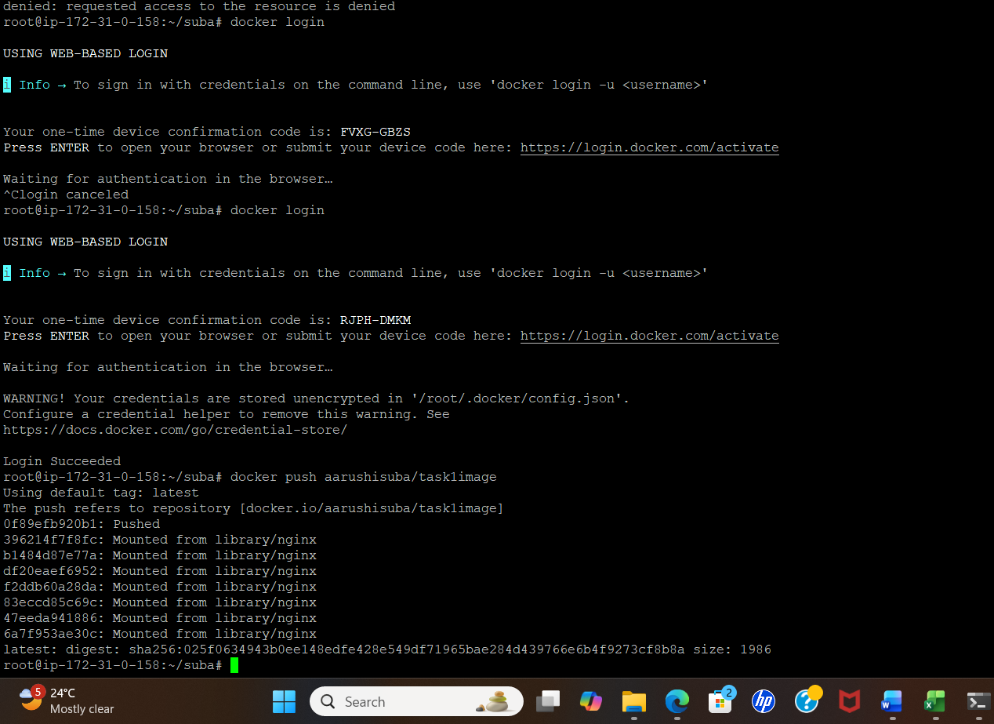
- 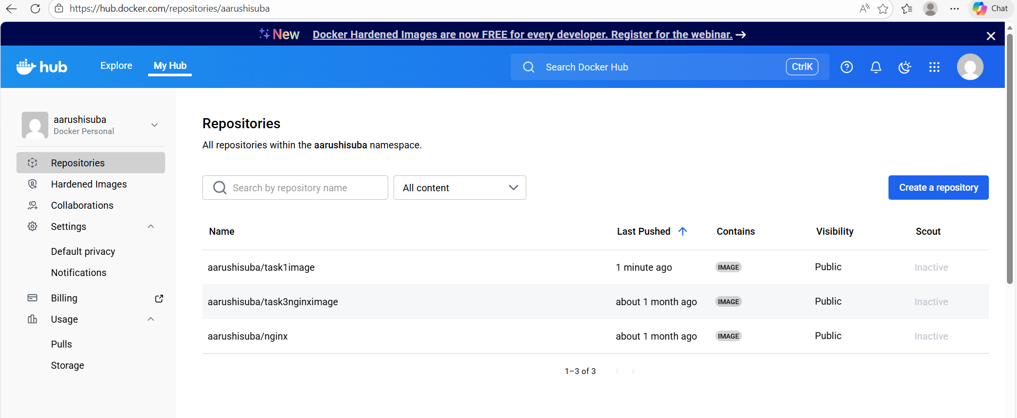
- How do you pull the same image back from the registry to another system or environment?
